1.Open and display the image “dog.jpeg”. Convert the image in to numpy array, so that i can be used in further processing.

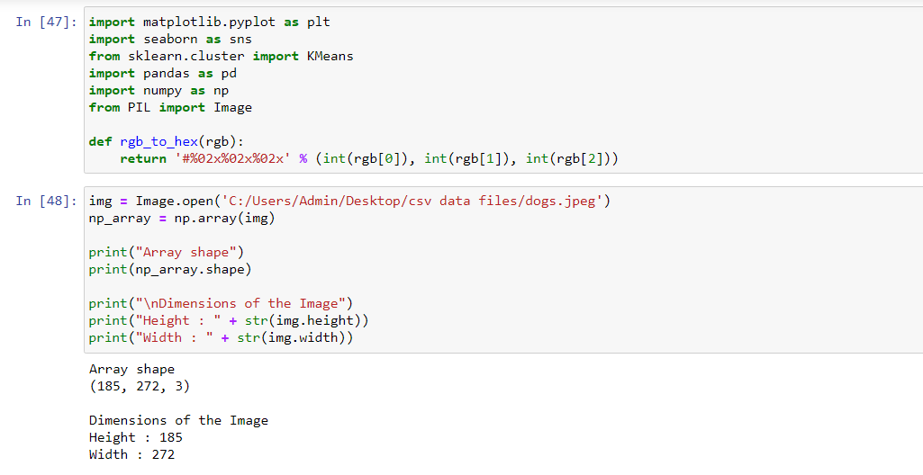

2. Find out the dimensions of the image and convert it in to a two-dimensional array



3. 3.Use kmeans clustering with k set to 3 and cluster the image.

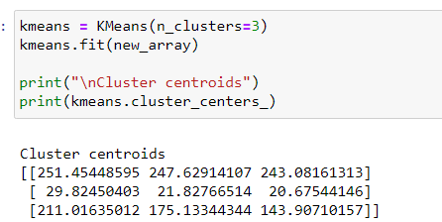

4. 4. Predict the cluster label of every pixel in the image and plot it back as an image.

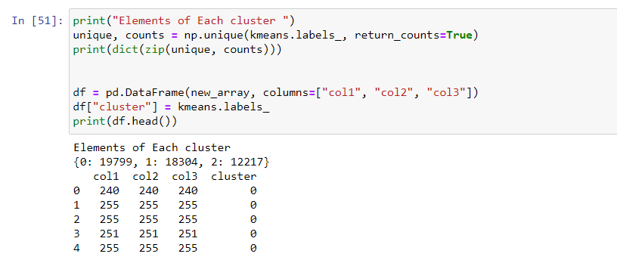

5. 5. Find out the three dominant color in the image

